Your teens want to join Youth Bible Quizzing! Don't let them miss out!
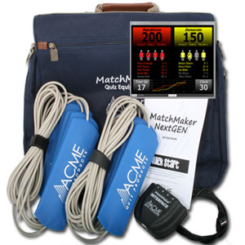
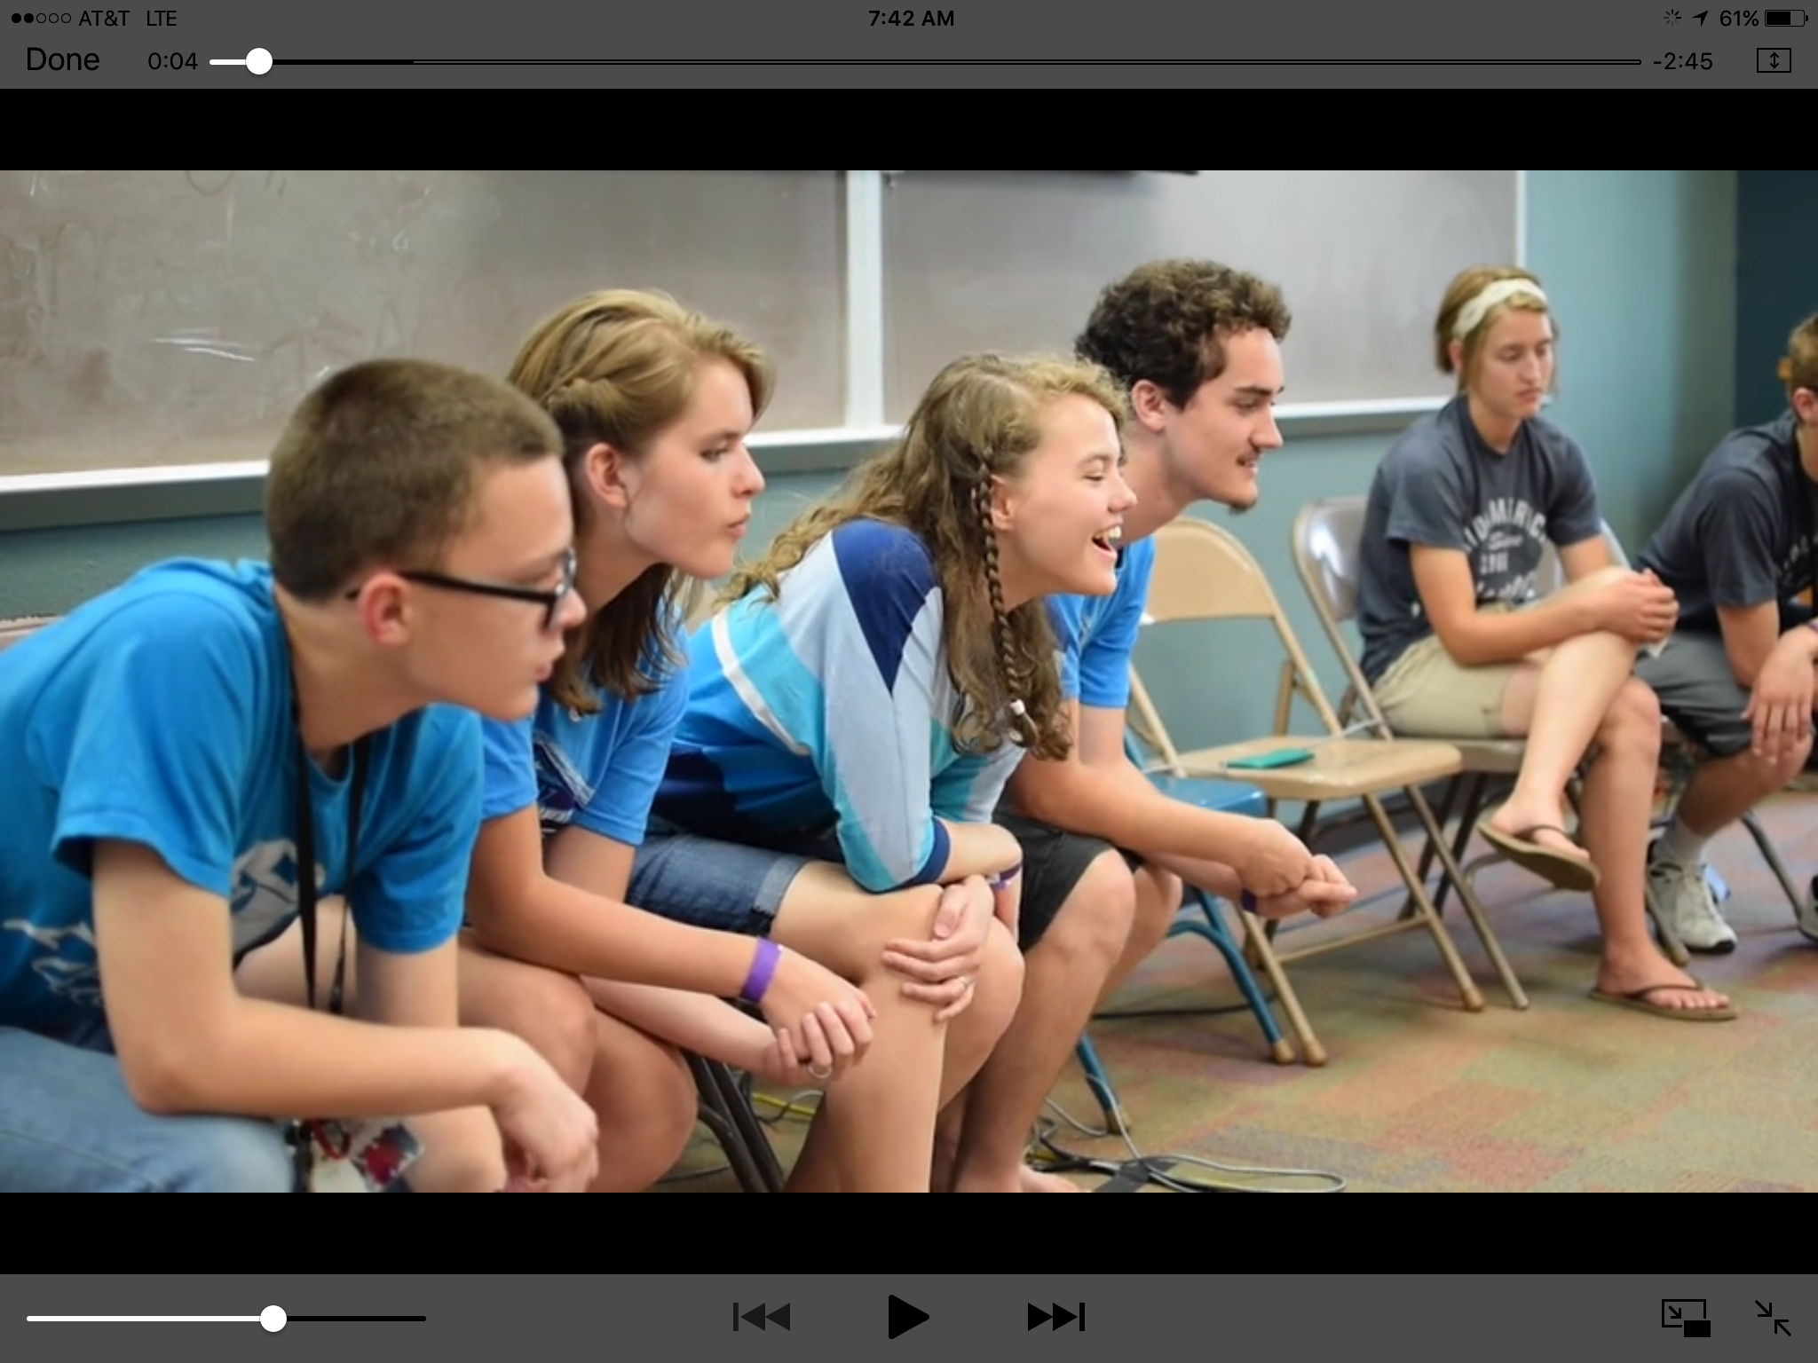
More and more teenagers and youth leaders are realizing just what an impact quizzing can have in their lives and in the lives of people around the world! Quizzing is an exciting way to encounter God!

STUDY MATERIALS
Order at NPH.com:
- Novice Quizzer Kit for new quizzers
- Experienced Quizzer Kit for returning quizzers
- Coach’s Kit for coach
LEARN MORE
Visit the quiz blog: teenbiblequiz.com

EQUIPMENT
(2 options)
AcmeQuiz.com. Two-team interface with 2 sets of 4 pads @ $270
Quizstuff.com. Two-team interface with 2 sets of 5 pads @ $275

Recruit teens
Visit nyiconnect.com/youth-quizzing for a “Promo Kit”; read the “Getting YBQ Started…” post.
1

Order books
Visit NPH.com to order Quizzer and Coach’s kits. These kits include Scripture Portions and Practice Questions
2

Study/Practice
Bible Study/devotionals during summer, start practicing in August
(~1 chapter/week)
3
Louisiana district May 2019

Youth Bible Quizzing
Bible study, mentoring, competition, fellowship, discipleship, and mission

So, what do I do now? How to get started:
“An exciting and fun way to learn God's Word!”
There are very few other areas in which young people are able to socialize with so many other godly youth on a regular basis. While the ministry helps them mature in intellect, attitude, emotions, and spiritually, it is also extremely competitive and exciting!
The 3 Biggest Myths About Youth Bible Quizzing
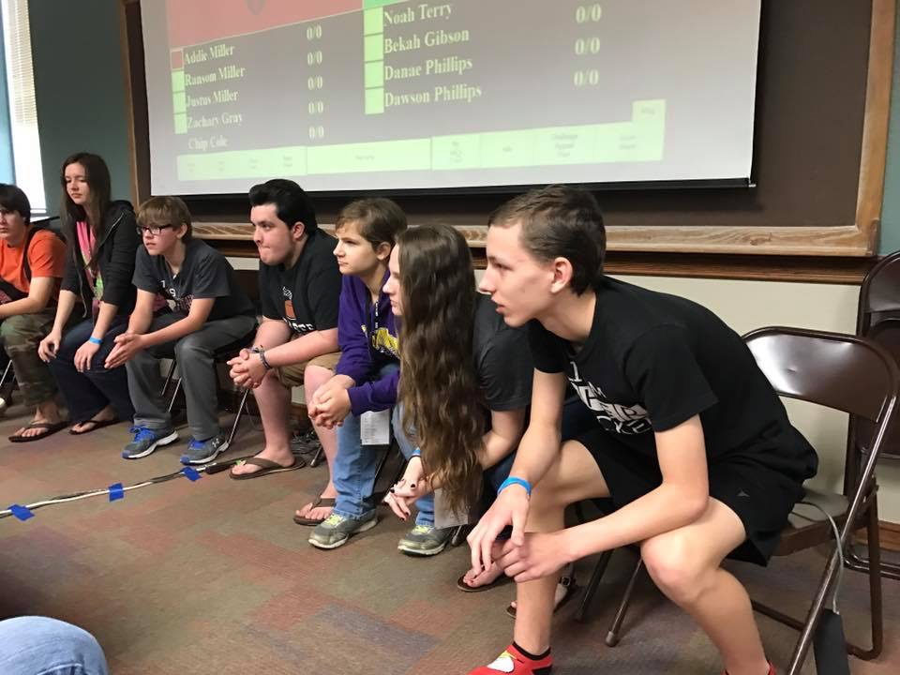
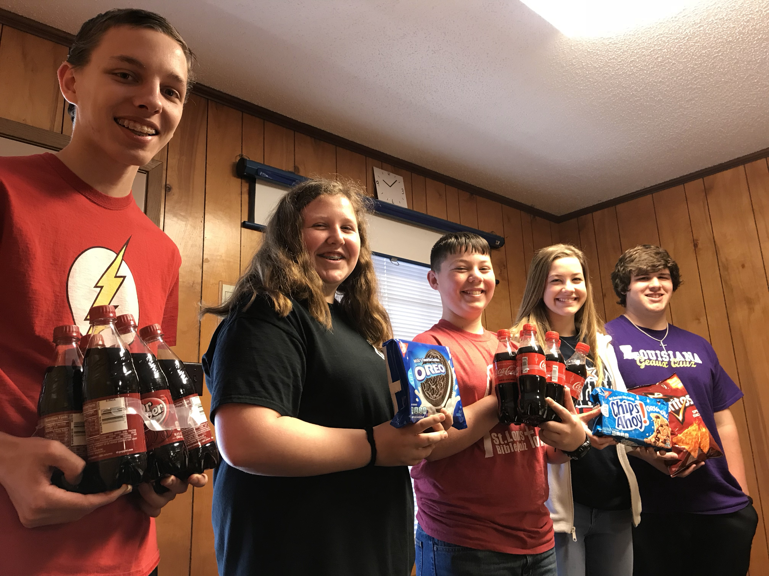
- "I'm not good at memorizing", "You need to memorize a lot for Quizzing": There are only 3 Memory Verse questions per game. While some quizzers choose to learn the Memory Verses, most do not. Also, questions in competition don't need to be answered word-perfect.
Louisiana district May 2019
- "I'm not smart enough to Quiz": It’s a game, not a test! You don't need to know the answer to every question! (The most questions anyone can answer in a game is 4, anyway!) Regardless, the point is to learn God's Word and have fun while being a part of a team.
- "I don't have time for Quizzing": Really? All you need is 15 minutes a day to read a chapter and review practice questions. You could always trade 15 minutes of social media for God's Word. Or read while traveling to school.

2019-20 Louisiana District Bible Quiz Schedule
September 7 Hebrews 1-3 9am @ Rocky Creek
October 5 Hebrews 1-6 9am @ Rocky Creek
November 9 Hebrews 1-9 9am @ Rocky Creek
Dec 6-7 Hebrews 1-11* St. Louis Invitational
January 11 Hebrews – 1 Peter 2 9am @ Rocky Creek
February 8 Hebrews – 1 Peter 5 9am @ Rocky Creek
March 7 Hebrews – 2 Peter 3 9am @ Rocky Creek
Contact David Phillips at d4phillips@gmail.com to learn more or if you will be joining us at the September 7 quiz!
*Tentative.

