Your teens want to join Youth Bible Quizzing! Don't let them miss out!
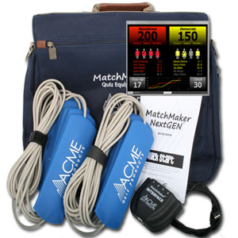
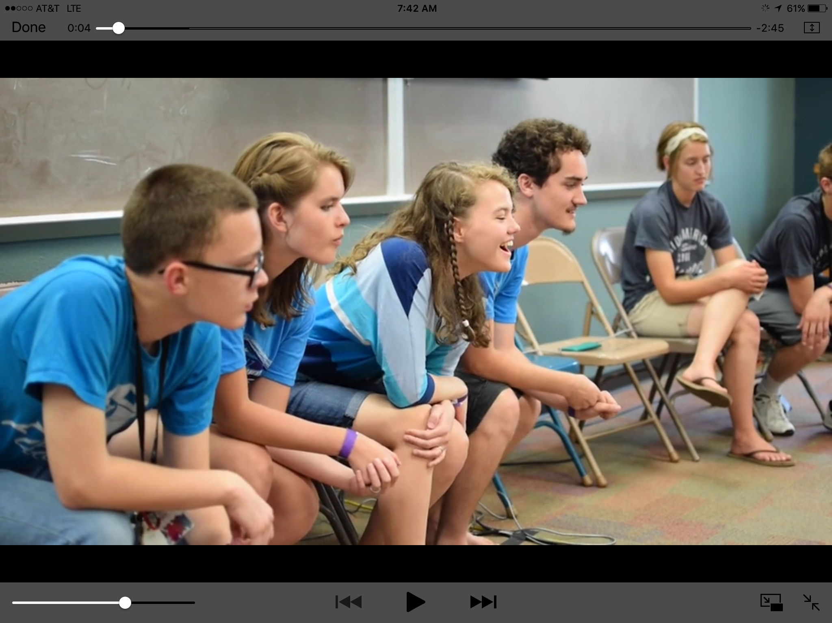
More and more teenagers and youth leaders are realizing just what an impact quizzing can have in their lives and in the lives of people around the world! Quizzing is an exciting way to encounter God!

STUDY MATERIALS
Order at NPH.com:
- Scripture Portion for each teen
- Beginner's Guide for new quizzers
- Practice Questions for coach
- Daily Devotional for each teen
- Audio CD of scripture for select teens
- Coach's Ideabook for coach

EQUIPMENT (optional)
Order Quiz Pads at AcmeQuiz.com. Two-team interface with 2 sets of 4 pads @ $270

Recruit teens
Show the Bible Quiz promo video at church: https://vimeo.com/195705624
1

Order books
Visit NPH.com to order Scripture Portions, Beginner's Guide, & Practice Questions
2

Study/Practice
Bible Study/devotionals during summer, start practicing in August
(1 chapter/week)
3
Louisiana district May 2018

Teen Bible Quizzing
Bible study, mentoring, competition, fellowship, discipleship, and mission

So, what do I do now? How to get started:
“An exciting and fun way to learn God's Word!”
There are very few other areas in which young people are able to socialize with so many other godly youth on a regular basis. And while the ministry helps them mature in intellect, attitude, emotions, and spiritually, it is also extremely competitive and exciting!
The 3 Biggest Myths About Teen Bible Quizzing
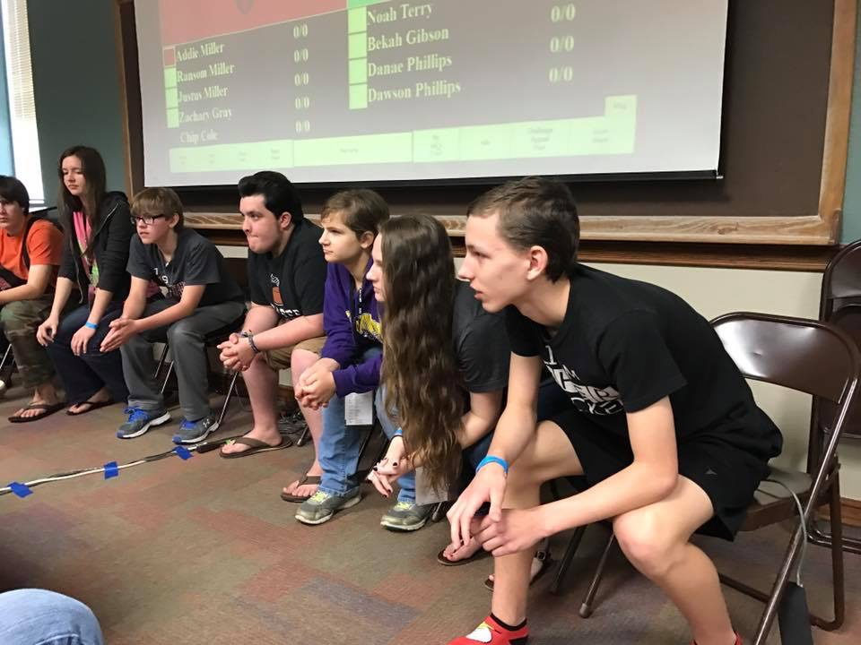
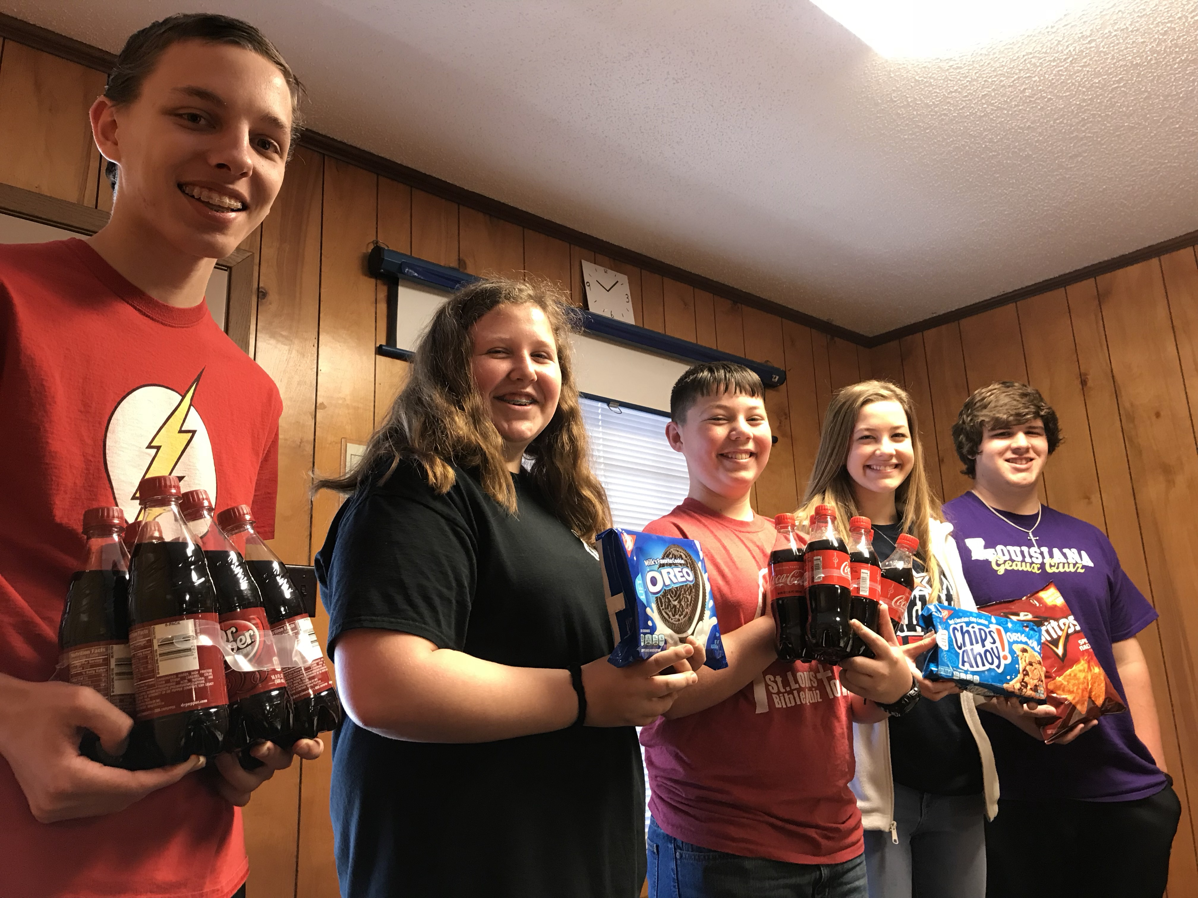
- "I'm not good at memorizing", "You need to memorize a lot for Quizzing": There are only 3 Memory Verse questions per game. While some choose to learn the Memory Verses, most questions in competition don't need to be answered word-perfect.
Louisiana district May 2018

2018-19 Louisiana District Bible Quiz Schedule
September 1 John 1-3 9am @ Rocky Creek
October 6 John 1-6 9am @ Rocky Creek
November 9 John 1-9 9pm @ Revivalution
Nov 30 - Dec 1 John 1-11 St. Louis Invitational
January 12 John 1-14 9am @ Rocky Creek
February 9 John 1-18 9am @ Rocky Creek
March 2 John 1-21 9am @ Rocky Creek
Contact David Phillips at d4phillips@gmail.com to learn more or if you will be joining us at the September 1 quiz!
- "I'm not smart enough to Quiz": It’s a game, not a test! You don't need to know the answer to every question! (The most questions anyone can answer in a game is 4, anyway!) Regardless, the point is to learn God's Word and have fun while being a part of a team.
- "I don't have time for Quizzing": Really? All you need is 15 minutes a day to read a chapter and review practice questions. You could always trade 15 minutes of social media for God's Word. Or read while traveling to school.

